**Assignment Day3 – 16 Aug 2020**

**PROJECT1:** Deploying a web server in Windows instance

Task 1:Create a windows instance using AMI :Windows 2012 R2 base

Task 2:Launch the Windows instance using RDP

Task 3:Install IIS web server using Powershell ISE

Note:Simply copy the command below and paste in the powershell ISE to install the IIS web server.

!!!!Powershell is case sensitive.

Install-WindowsFeature -name Web-Server -IncludeManagementTools

Task 4:Verify successful installation of IIS Web Server

Note :You should be able to see the Internet Information Services Web page when you paste the public IP

into the browser.

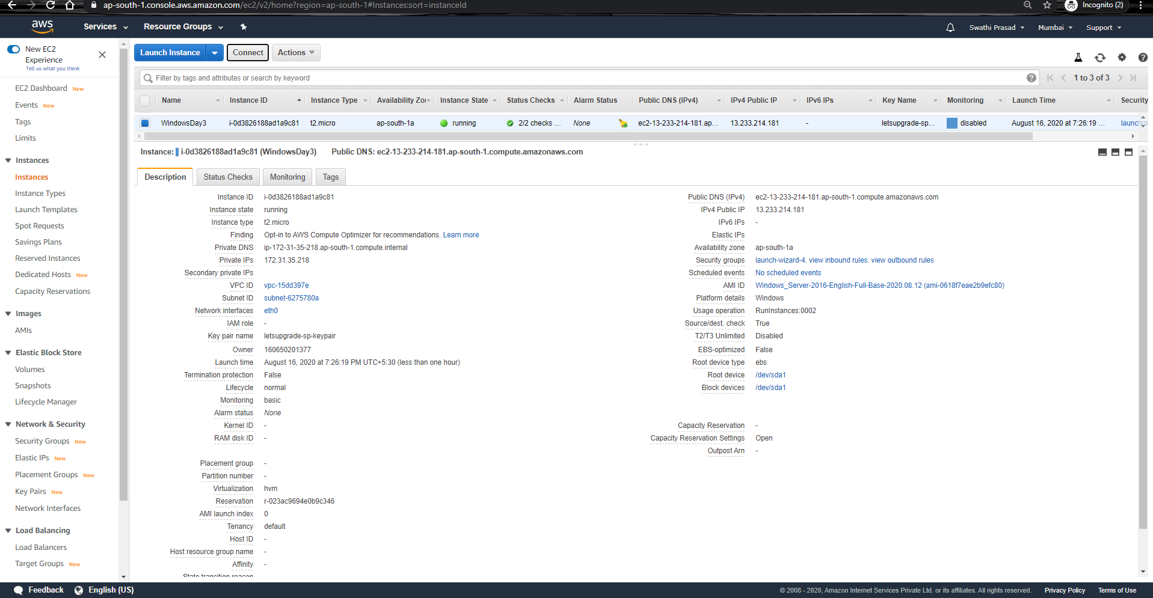

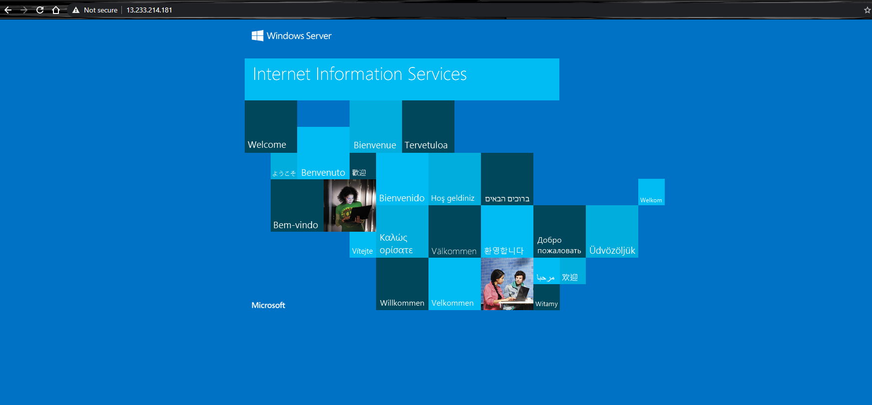

PROJECT 2: Deploying Ubuntu Server 18.04 LTS (HVM)

Task 1:Create a windows instance using AMI :Ubuntu Server 18.04 LTS (HVM)

Task 2:Download and install MobaXterm Portable Edition

Task 2:Launch the Ubuntu instance using SSH

Note:Username is ubuntu

Task 3:Install ngnix web server using bash

Note:Simply copy the command below and paste in the bash to install the ngnix web server.

sudo apt-get -y update

sudo apt-get -y install nginx

Task 4:Verify successful installation of ngnix

Note :You should be able to see the Welcome to ngnix Web page when you paste the public IP into the

browser.

